Robot V 1.21

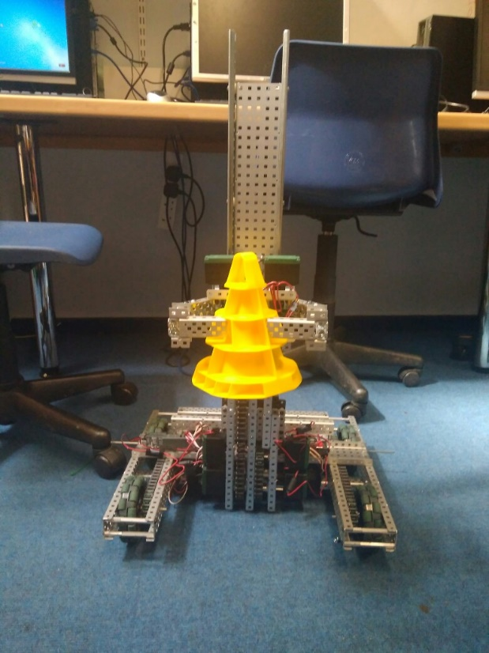

SPECIFICATIONS:

* 6 Motor HS drive
* Two drive chains
* 4 wheels
* Aluminium structure
* 4 motor lift
* Two stage lift
* 2 motor claw

DIMENTIONS:

17.5” * 15” * 17.5 when not extended

**What needs to be changed:**

* Improve claw
* Add a third stage

By Robbie Buxton

13/7/2017 – 16:29

**Overview:**

For this version of the robot we have managed to fix the problem affecting the movement of the lift downward. For greater detail have a look at the 1st document of problems we encountered on page (###). We have also added a claw meaning that our robot is now able to pick up cones and stack them. However, it does not do this flawlessly and needs some improvement. We also need to add a third stage to the lift to increase the speed of lifting and to increase the maximum height however we cannot do this until the parts arrive.

**WHAT HAS BEEN CHANGED:**

* Fixed lift problem
* Added claw